# Laundry Icons Decoded

By [**Mike Acton**](https://plus.google.com/105595823502776413734) and Daughter (Thanks: [Ed Bartley](https://plus.google.com/117146957319895014451))

See: <https://plus.google.com/105595823502776413734/posts/RUs5PQEPXgU>

See also: <http://www.textileaffairs.com/c-common.htm>

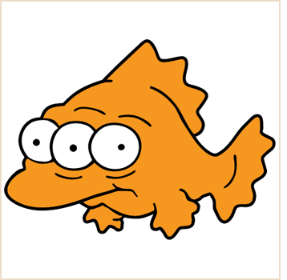 Clothes suitable for a king



http://www.textileaffairs.com/symbols/small/s_mw30cd.jpgClothes suitable for a Cyclops king

http://www.textileaffairs.com/symbols/small/s_mw40cd.jpgClothes suitable for a human king

http://www.textileaffairs.com/symbols/small/s_mw50cd.jpgClothes suitable for a mutant fish king

http://www.textileaffairs.com/symbols/small/s_mw60cd.jpgClothes suitable for someone human king with glasses

http://www.textileaffairs.com/symbols/small/s_mw70cd.jpgClothes suitable for human king with eyebrow issues

http://www.textileaffairs.com/symbols/small/s_mw95cd.jpgClothes suitable for insect king

http://www.textileaffairs.com/symbols/small/s_mw_ppres.jpgYou can wear these clothes after you decapitate the king.

http://www.textileaffairs.com/symbols/small/s_mwgentle.jpg You can wear these clothes after you decapitate the king and deliver the head to me on a silver platter.

http://www.textileaffairs.com/symbols/small/s_hndw.jpgYou can wear these clothes only after you steal the crown right off the king’s head.

http://www.textileaffairs.com/symbols/small/s_w_donot.jpgClothes suitable only for kings that secretly fight crime in the night while hiding their identity under a mask.

http://www.textileaffairs.com/symbols/small/s_b_any.jpg Knowledge of trigonometry required to wear these clothes.

http://www.textileaffairs.com/symbols/small/s_b_nonchl.jpg These clothes can be rendered most efficiently using triangle strips.

http://www.textileaffairs.com/symbols/small/s_b_dont_s.jpgBe careful of attracting mice while wearing these clothes.

http://www.textileaffairs.com/symbols/small/s_td_norm.jpg Special outfit for use only when pressing the big, red button.

http://www.textileaffairs.com/symbols/small/s_td_nor_l.jpg Clothes suitable for DJs only.

http://www.textileaffairs.com/symbols/small/s_td_nor_m.jpg Clothes suitable for human peeping through windows.

http://www.textileaffairs.com/symbols/small/s_td_nor_h.jpg Clothes suitable for mutant fish peeping through windows.

http://www.textileaffairs.com/symbols/small/s_td_nornh.jpg Clothes suitable for ninja peeping through windows.

http://www.textileaffairs.com/symbols/small/s_td_ppres.jpg Clothes suitable for television news anchors.

http://www.textileaffairs.com/symbols/small/s_td_gentl.jpgClothes suitable for eating TV tray dinner in front of TV news.

http://www.textileaffairs.com/symbols/small/s_td_donot.jpgClothes suitable for hipters that refuse to own TVs.

http://www.textileaffairs.com/symbols/small/s_dr_donot.jpgClothes not suitable for washing windows.

http://www.textileaffairs.com/symbols/small/s_dr_line.jpg Clothes so small they fit in an envelope. (Warning to fathers.)

http://www.textileaffairs.com/symbols/small/s_dr_drip.jpg Clothes susceptible to blowing around and exposing self when standing over air vent.

http://www.textileaffairs.com/symbols/small/s_dr_flat.jpg Clothes suited for characters in arcade games; expect mocking.

http://www.textileaffairs.com/symbols/small/s_dr_shade.jpg Clothes suitable for Justin Bieber.

http://www.textileaffairs.com/symbols/small/s_wr_donot.jpg Bow ties are not cool.

http://www.textileaffairs.com/symbols/small/s_ir_tall.jpg ‘A’ These clothes only suitable for attractive people.

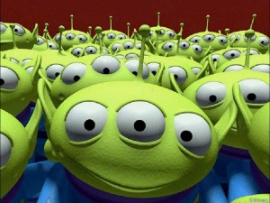http://www.textileaffairs.com/symbols/small/s_ir_talll.jpg These clothes attract Cyclops spies (looking around corners)

http://www.textileaffairs.com/symbols/small/s_ir_tallm.jpg These clothes attract human spies (looking around corners) *<- Thanks, Ed.*

http://www.textileaffairs.com/symbols/small/s_ir_tallh.jpg These clothes only suitable for Toy Story aliens.

http://www.textileaffairs.com/symbols/small/s_ir_nostm.jpg These clothes not suitable for big, fat people with small, skinny legs.

http://www.textileaffairs.com/symbols/small/s_ir_dontt.jpg’A’ These clothes only suitable for not-attractive people.

http://www.textileaffairs.com/symbols/small/s_dc_circle.jpg These clothes only suitable for watching the Hudsucker Proxy.

http://www.textileaffairs.com/symbols/small/s_dc_a.jpg These clothes suitable only for students with 4.0 average.

http://www.textileaffairs.com/symbols/small/s_dc_f.jpg These clothes suitable for students that just don’t give a damn.

http://www.textileaffairs.com/symbols/small/s_dc_p.jpg These clothes suitable for parents that insist on putting those bumper stickers on their car about their kid being something of the month at their local school.

http://www.textileaffairs.com/symbols/small/s_dc_sc.jpgClothes suitable for right-handed person while speaking on cell phone.

http://www.textileaffairs.com/symbols/small/s_dc_rm.jpgClothes suitable for right-handed graduate.

http://www.textileaffairs.com/symbols/small/s_dc_lh.jpg Clothes suitable for left-handed person while speaking on cell phone.

http://www.textileaffairs.com/symbols/small/s_dc_ns.jpgClothes suitable for left-handed graduate.

http://www.textileaffairs.com/symbols/small/s_dc_donot.jpgClothes suitable for people who neither own a cell phone nor have graduated.